Welcome to your Rutland North police e-newsletter. Here you will find all of the latest news from a Rutland North policing perspective.
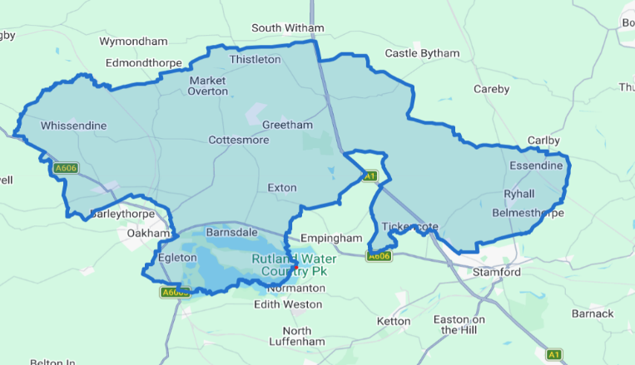
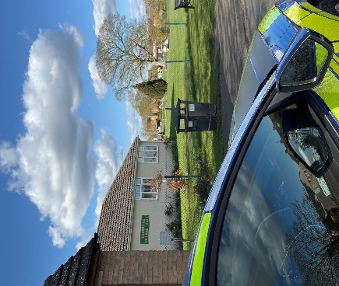

What matters to you

We have listened to you and the concerns you have raised through surveys, community consultations and analysing crime trends.

Rutland North Newsletter
June 2026 | PC Bland and PCSO Lyall
Using this data, we have created the following Rutland North priorities that the Dedicated Neighbourhood Team will focus their efforts on:

Page 1

Rutland North Beat

Priority 1: Burglary:
In June, PC Bland and I have been focused on tackling anti-social behaviour through proactive patrols, targeted engagement with those involved, and close partnership working with local residents. We have responded to reports, carried out reassurance visits, and gathered information to help identify those responsible. Where appropriate, positive action has been taken, including the issuing of Section 59 warnings to address the anti-social use of vehicles.

Priority 2: Road Safety: During June, PC Bland and I have been carrying out dedicated speed enforcement activities across the Rutland Safety Beat area, focusing on locations highlighted by residents as areas of concern. We have conducted speed monitoring, engaged with drivers about the importance of adhering to speed limits, and provided reassurance to local communities. We have also worked alongside partner agencies to identify road safety issues and gather information to support future enforcement and educational initiatives.
Priority 3: Rural crime:
What We Have Done: During June, PC Bland and I have been working to tackle rural crime through high-visibility patrols across rural locations, including farms, isolated properties, and areas vulnerable to theft and poaching. We have engaged with farmers, landowners, and members of the rural community to discuss concerns, provide crime prevention advice, and encourage the reporting of suspicious activity. We have also carried out reassurance visits and gathered intelligence to help identify and disrupt those involved in rural crime.

During June, PC Bland and I have had a busy month responding to a range of incidents and concerns across the beat. This has included dealing with incidents on the A1, addressing reports of anti-social behaviour, and tackling various neighbourhood issues raised by residents. Alongside responding to calls for Police, we have carried out reassurance patrols, engaged with members of the community, and worked with partner agencies to resolve ongoing concerns. Our continued efforts aim to keep our communities safe, provide support to those affected by crime and anti-social behaviour, and maintain a visible policing presence throughout the area.

0 Burglary related offences
1 reports of rural crime 2 report of road safety

June 2026

Rutland North Newsletter

Crime data for the last 30 days

In the last 30 day there have been:

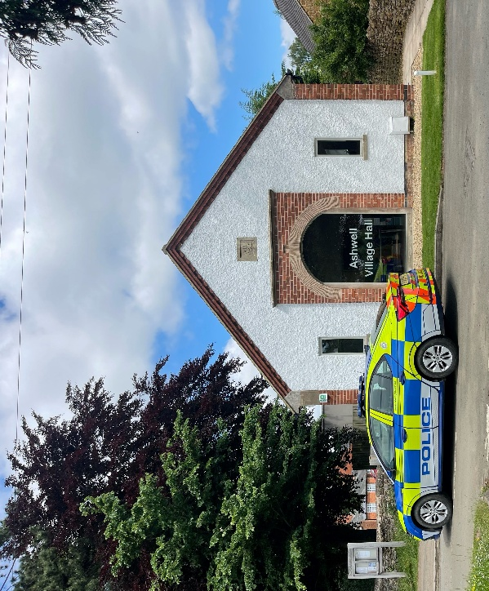


Community engagements—come along and meet the team!

26.07.3036 - 14:30- Ashwell village hall beat surgery

