Welcome to your Oakham & Barleythorpe police e-newsletter. Here you will find all of the latest news from an Oakham & Barleythorpe policing perspective.
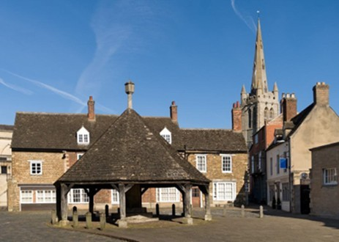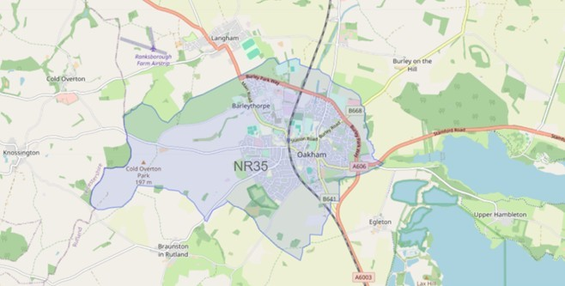

What matters to you

We have listened to you and the concerns you have raised through surveys, community consultations and analysing crime trends.

Oakham & Barleythorpe Newsletter
May 2026
Using this data, we have created the following Oakham & Barleythorpe priorities that the Dedicated Neighbourhood Team will focus their efforts on:

Page 1

Oakham & Barleythorpe Newsletter

Priority 1: Anti-social behaviour (ASB): You said: Anti-social behaviour in and around Oakham & Barleythorpe is becoming more frequent in certain areas.
What we have done: During April, myself and PC Hughes have carried out high-visibility patrols in identified ASB hotspot areas, engaging with residents and local businesses to address ongoing concerns. We have conducted joint patrols and targeted interventions, speaking with individuals involved, issuing appropriate advice and warnings, and offering reassurance to the community.

Priority 2: Road Safety: You said: Speeding vehicles on Oakham & Barleythorpe roads is a priority you want us to address, specifically the lack of adherence to 30mph zones.
What We Have Done: This past month, myself and PC Hughes have been actively addressing road safety concerns, with a particular focus on speeding. We have carried out targeted speed enforcement in identified hotspot areas, using both mobile speed detection equipment and high-visibility patrols to deter offending drivers. We’ve also engaged with members of the community to raise awareness of the dangers of speeding and encourage safer driving behaviours. Where necessary, appropriate enforcement action has been taken, with the aim of improving road safety, reducing risk, and helping to keep our local roads safe for everyone.

Priority 3: Drug dealing/taking: You said: Reports of drug dealing/ taking in and around Oakham & Barleythorpe.
What We Have Done:
This past month, myself and PC Hughes have been working to tackle drug dealing within the area through a combination of high-visibility patrols, intelligence-led activity, and partnership working. We have focused on known locations and individuals of concern, gathering information from the community and acting on reports to disrupt criminal activity. This has included stop checks, targeted patrols, and working alongside partner agencies to address underlying issues. Our continued efforts are aimed at reducing drug-related harm, preventing further offending, and maintaining a safe environment for local residents.

This past month we have seen-

3 drug related offences
0 reports of Road Safety 2 report of Anti-Social Behaviour
Anti-social behaviour
As we move into warmer weather, we anticipate a potential increase in reports of anti-social behaviour, particularly involving young people spending more time outdoors. We urge parents and guardians to speak with their children about the impact of ASB and the importance of respectful behaviour within the community, helping to prevent incidents before they occur.

If you’ve witnessed antisocial behaviour, please report it to us. Report antisocial behaviour | Leicestershire Police (leics.police.uk)
Community engagements—come along and meet the team!
23.06.2026– Beat surgery at Oakham Library, a chance to meet your neighbourhood team and rep567890- any concerns to the Police.

