
Priority 1
Western Ward

Newsletter

#YouSaid
-

What matters to you - Priorities

Issue
June 2026 - Introduction

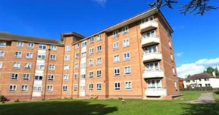

PCSO Pete SMITH
PCSO Sally-Ann MORGAN
PCSO Sabra BABAI
PCSO Andy BROWN
PCSO Grant JARVIS

PS Simon WALTERS
PC Dave MARTIN
PC Georgia POWELL
PC Callum JOHNSTON
PC Alex ALDRICH
PC Dan JARMAN

Dangerous and illegal use of vehicles around the Western Ward continue to be reported and raised as concerns by local residents. Speeding, E-bikes and E-Scooters and dangerous parking outside Primary Schools have all been highlighted.
Actions
The beat team have continued to target areas where this type of issue is most prevalent

Priority 2
Retail crime continues to be a problem for our shops across the Western ward which is causing staff to feel unsafe whilst at work.
Actions
We continue to maintain a good working relationship and open communication on sharing information to tackle the persistent offenders bring them to justice.

Priority 3
The community in the area of Styon Road, Kemp Road and Lamen Road tell us that youths are regularly causing Anti-Social Behaviour in and around the grassed Play area. Motorcycle gatherings causing excessive noise, Vandalism/damage to Property, targeting of a vulnerable residents and incidents of animal cruelty have all been reported.
Actions
High visibility patrols on dedicated days and times throughout the month to identify perpetrators.

Page 1

Western Ward
newsletter

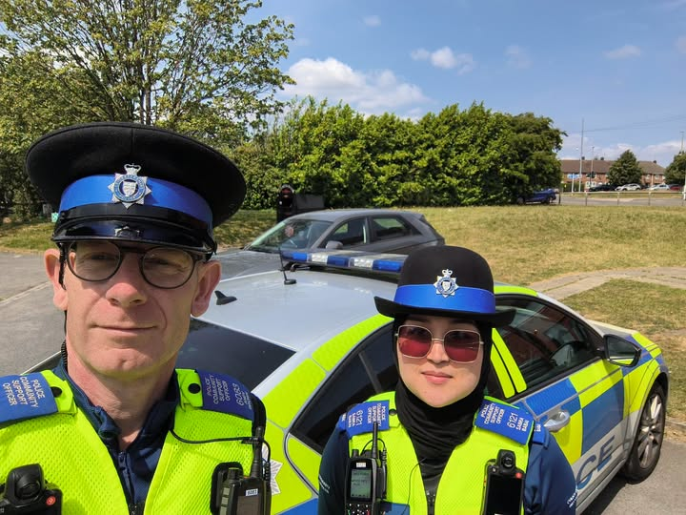

REMEMBER: It is illegal to ride an e-scooter without a licence and insurance. AND you cannot license or insure an e-scooter making ALL! e-scooters ILLEGAL.

#YouSaidWeDid

Your PCSOs have been out and about across the Western Ward — both on foot and in the patrol car .
Foot patrols remain a vital part of neighbourhood policing, helping us gather valuable intelligence, engage with residents, and provide reassurance within our communities. Here's a snapshot of today's activity:
PCSO Sabra hosted a welcoming Beat Surgery at the New Parks Salvation Army
PCSO Brown carried out reassurance visits with local businesses and shops
PCSO Sabra responded to a welfare concern. A safeguarding referral will be submitted to ensure appropriate support and follow-up is provided
PCSO Sabra also joined Leicester City Council colleagues on a partnership patrol around New Parks, helping to deter anti-social behaviour and support the local community
PCSO Brown conducted CCTV enquiries in relation to a report of anti-social behaviour
PCSO Brown arranged upcoming school visits to continue engaging with local children and young people

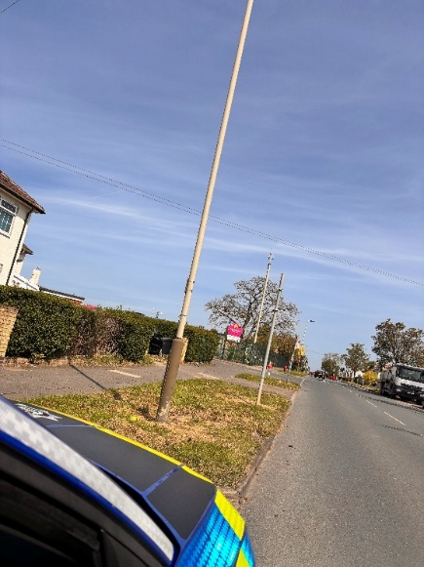

Page 2

Western Ward
newsletter

#YouSaidWeDid

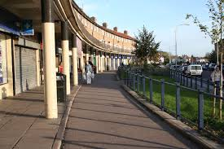
Your local officers have been busy throughout June, tackling crime and addressing community concerns.

- Working alongside Response colleagues, we located and arrested a priority offender. A great example of teamwork ensuring those wanted are brought before the courts.

Officers also stopped a vehicle and identified multiple offences, including:
Driving otherwise than in accordance with a licence by failing to display L plates
No insurance
The vehicle was seized, and the driver has been reported for offences.

- We attended a report of criminal damage, where windows at a property had been smashed. The property has since been secured and boarded up, and enquiries are ongoing.

In addition, officers have:
Conducted warrant arrest attempts
Begun work into a potential cuckooing concern on Tatlow Road, safeguarding vulnerable individuals and disrupting exploitation

Thank you to members of the public who continue to share information with us – your support makes a real difference.

#YouSaidWeDid

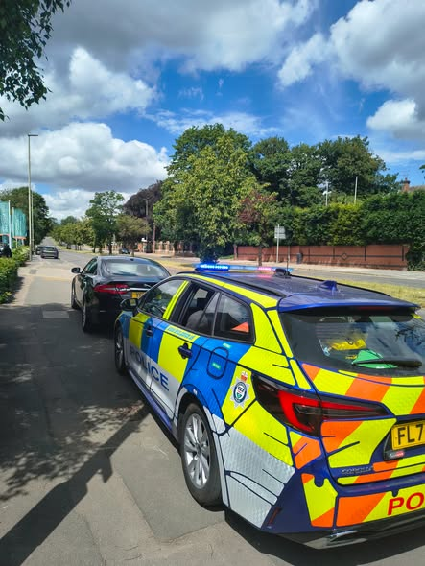

A successful stop search of a vehicle in Braunstone Frith where the possession of drugs and a dangerous weapon were seized and an arrest was made.

Page 3

Western Ward
newsletter

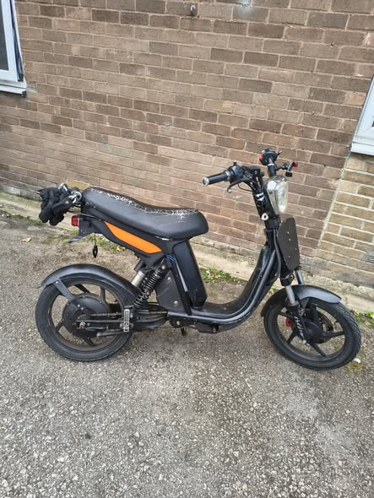
PCSO Sabra witnessed a motorbike being ridden on the pavement, putting pedestrians at risk. The bike was immediately seized under Section 165 Road Traffic Act after the rider failed to provide a driving licence or insurance.

This marks two motorbikes seized in just two days by the Western Wards team. The other was seized on Styon Road by Neighbourhood Officer PC Callum 4374. Another strong result for the team and for community safety.

Cropston Close
Officers have located and seized a vehicle that was displaying false registration plates - Focusing on your beat priorities!
The vehicle is believed to be linked to wider criminal activity and has been recovered for detailed forensic examination as part of ongoing enquiries.
We’d like to reassure the community that proactive work like this helps us disrupt criminality and keep our neighbourhoods safe.

#YouSaidWeDid

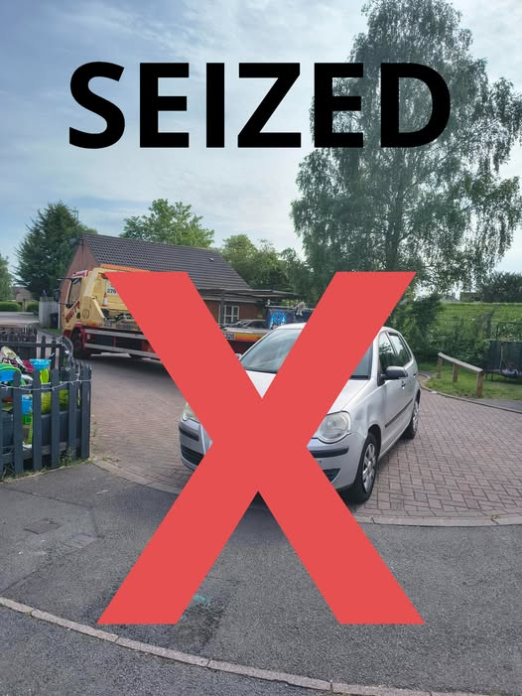

Page 4

Western Ward
newsletter

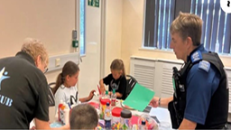
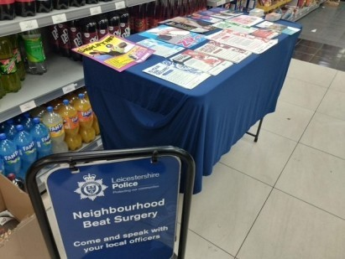

News And Community Events




Page 5 The End – Thank you for reading

06/07/26 Beat surgery at Braunstone Frith Recreation Centre 09.00-11.00
15/07/26 Beat surgery New Parks Library 18.00-19.00
16/07/26 Beat Surgery at Team HUB St Oswalds Road 10.00-13.00
24/07/26 Beat Surgery at St Annes 10.00-12.00
24/07/26 Beat Surgery at Co Op Aikman Avenue 17.00-18.00

Upcoming Community Engagements

