Welcome to your Rutland North police e-newsletter. Here you will find all of the latest news from a Rutland North policing perspective.
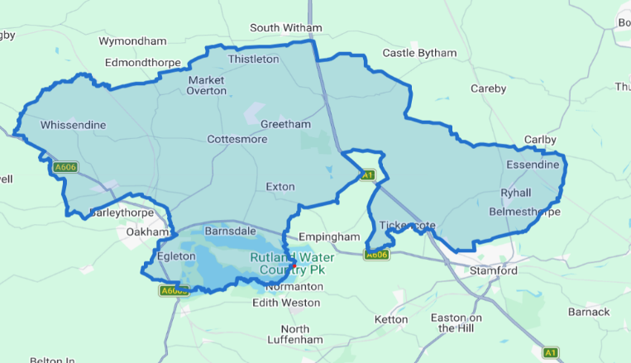
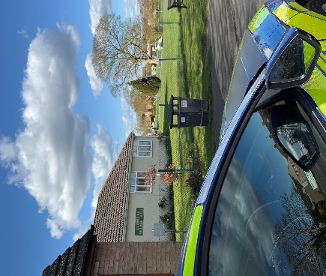

What matters to you

We have listened to you and the concerns you have raised through surveys, community consultations and analysing crime trends.

Rutland North Newsletter
April 2026 | PC Bland and PCSO Lyall
Using this data, we have created the following Oakham & Barleythorpe priorities that the Dedicated Neighbourhood Team will focus their efforts on:

Page 1

Rutland North Beat

Priority 1: Burglary You said: Burglary is a continuous issue on the Rutland North Beat
Over the past month, PC Bland and I have focused on reducing burglaries across the NR36 beat through targeted high-visibility patrols, reassurance visits, and proactive engagement with affected residents. We carried out door-to-door crime-prevention checks, shared security advice, and supported local Neighbourhood Watch groups to strengthen community awareness.
Priority 2: Road Safety: You said: Speeding vehicles on the Rutland Safety Beat roads is a priority you want us to address, specifically the lack of adherence to 30mph zones.
What We Have Done: Over the past month on the Rutland North beat, PC Bland and I have focused on improving road safety through targeted speed enforcement operations, high-visibility patrols in identified collision-risk areas, and proactive engagement with residents concerned about speeding. We carried out regular checks in village hotspot locations, issued words of advice to motorists, submitted intelligence regarding repeat offenders and problem vehicles, and have also issued Section 59 warnings in response to anti-social driving.

Priority 3: Rural crime: You said: Reports of rural crime in and around Rutland North.
What We Have Done: Over the past month, PC Bland and I have taken proactive steps to tackle rural crime across the beat through regular high-visibility patrols in rural areas, farm visits, and engagement with landowners and residents. We have provided crime prevention advice relating to machinery, fuel and livestock theft, completed reassurance visits, and encouraged reporting of suspicious activity.

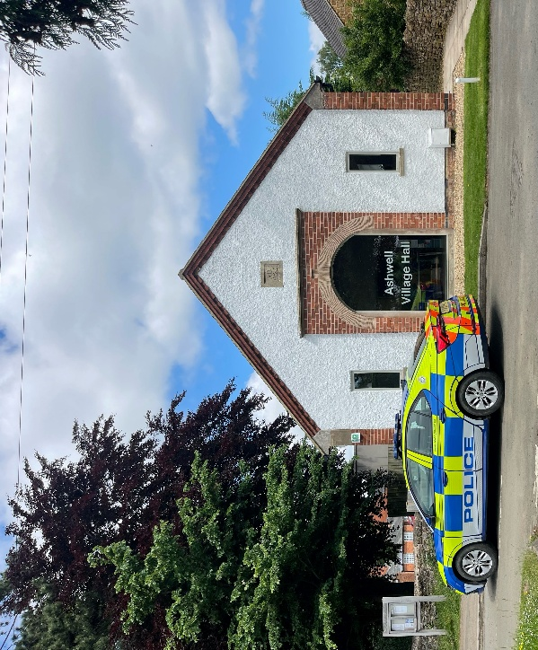
Over the past month on the 36 beat, PC Bland and I have focused on strengthening community safety and visibility, with a particular highlight being our involvement in recent local events such as the village coffee morning and the community safety drop-in at the parish hall. These sessions allowed us to share crime-prevention advice, answer questions, and build trust with residents. Alongside this, increased foot patrols and targeted reassurance visits led to several valuable intelligence reports about suspicious activity, helping us identify a known offender travelling through the area, which was swiftly acted upon by colleagues. Feedback from residents has been overwhelmingly positive, with many commenting that our presence at community events has made them feel more connected to and supported by their local policing team.

1 Burglary related offences
2 reports of rural crime 0 report of road safety

April 2026

Rutland North Newsletter

Crime data for the last 30 days

In the last 30 day there have been:

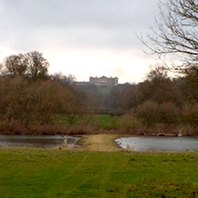

Community engagements—come along and meet the team!

27.05.2026-10:00- Beat Surgery at Cottesmore Village Hall

