

We have listened to you.

Issue:
Oct 26

Western Ward

Newsletter

Introduction

#YouSaid
-

What matters to you

PS Simon WALTERS

PC Dave MARTIN

PC Callum JOHNSTON

PC Georgia POWELL

PC Lee FLAVILL

PC Alex ALDRICH

PCSO Pete SMITH

PCSO Sally
-
Ann MORGAN

PCSO Sabra BABAI

PCSO Andy BROWN
PCSO Grant JARVIS
Priority 1
Dangerous and illegal use of vehicles around the Western Ward continue to be reported and raised as concerns by local residents. Speeding, E-bikes and E-Scooters and dangerous parking outside Primary Schools have all been highlighted.
Action
We will be still continuing to target people in relation to dangerous Vehicles and dangerous parking, Police and PCSO will be using Section 59 of the Police Reform Act 2002 provides a power to stop, seize and remove a motor vehicle that is being used, or has been used, in a manner that contravenes section 3 or section 34 of the Road Traffic Act 1988 and is causing, or is likely to cause, alarm, distress or annoyance to members of the public.
Priority 2
Retail crime continues to be a problem for our shops across the Western ward which is causing staff to feel unsafe whilst at work.
Actions
Shop thefts and staff feeling unsafe is still a priority and officer will still be tackling this issue with high visual patrols working closely with staff gathering CCTV, taking statements and bring suspect to justice
Priority 3
The community in the area of Styon Road, Keightley Road and Lamen Road tell us that youths are regularly causing Anti-Social Behaviour in and around the grassed Play area. Motorcycle gatherings causing excessive noise, Vandalism/damage to Property are regularly being reported.
Actions
The great work that has been done in this area by Luke Westell council ASB officer and the beat will continue patrol the area and challenging any anti-social behaviour.
Drug Dealers Blighting our communities, Action Taken

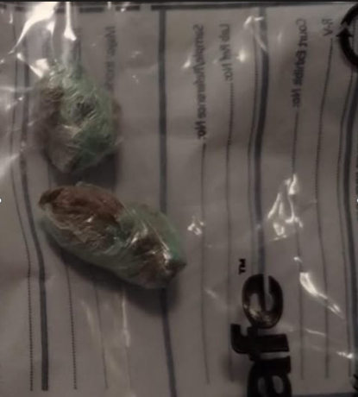
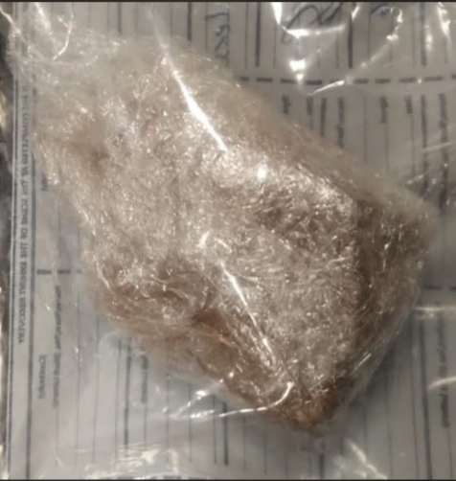

Beat Team and NPT (Neighbour Hood Priority Team) Great work
Report from the public in relation to address dealing drugs and male on push bike who has been seen dealing on Stokeswood park close to schools and
On the 9th Of October
Two addresses one Cropston Close and one Sacheveral Road, Police executed Drugs warrants in relation to community intelligence 2 Males were arrested in relation drugs supply offences Drugs Cash & weapons were seized, arrested suspects when handed over to CID great work by all officers involved
On The 24th Of October
After numerous reports from the public re unknown male dealer in and around comet Close and stokes wood Park, Beat Team & NPT officer developed intel identify and detained a male close to Pindar Road. After a Section 18 completed and a quantity of Class A Drugs were located
If you have any information that could prevent crime, or protect victims of Crime, please contact you beat team in person or via 101.

Or contact Crimestoppers on


Crime & ASB You could lose your property
Police, Council & Housing association are not afraid to taken Positive action and taken full possession of those who use their property in relation to Crime and ASB
This is part of an incremental approach to tackle crime and ASB

Upcoming beat event Activities

Beat Surgery at New Parks Salvation Army Center.
11:00AM - 12:00PM, Wed 04 November 2026
New Parks Salvation Army Centre, 330 Aikman Ave, New Parks, Leicester LE3 9PW

Beat Surgery New Parks Library
5:00PM - 6:00PM, Wed 18 November 2026
321 Aikman Avenue

Beat Surgery at One Stop Shop on Stephenson Drive
11:00AM - 11:00AM, Mon 23 November 2026
One Stop Shop, 155 Stephenson Drive, Leicester

#NeighbourhoodPolicing #SaferStreets #WesternWard
Follow us @LPWestLeicester

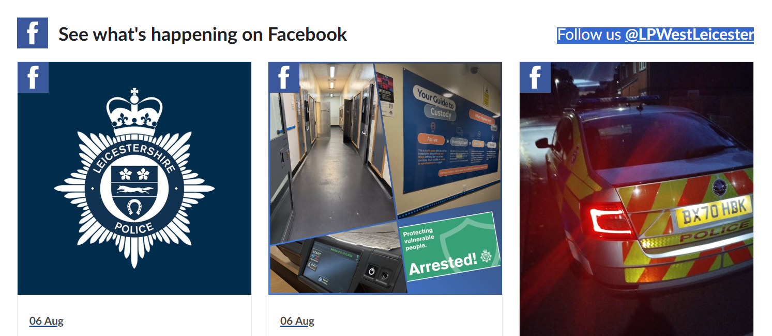
nts November 25

How to contact your Local Leicester City Council Noise Team

Local council 0116 4541001
www.leicester.gov.uk/planning-envionment-and-building-control/pollution-and-pests-leicester/noise-problem

loud music, parties and musical instruments dogs barking car and burglar alarms DIY, construction and demolition noise if it occurs at unreasonable times noise from bars, restaurants, clubs or equipment in commercial premises




Your Beat Team in action

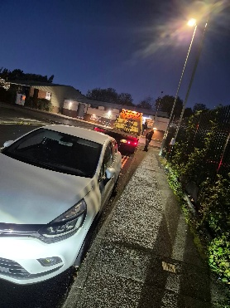
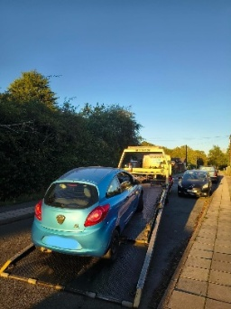
Stolen Car on Cloned Plates
concerned resident called in an abandoned vehicle the Scudamore Road Industrial estate, vehicle was located and checks on the registrations and VIM number were completed. The vehicle was confirmed stolen. And on cloned plates. Vehicle was recovered by Police and will be examined by our SOCO team

Community garden at Team HUB St Oswalds Road 28th September
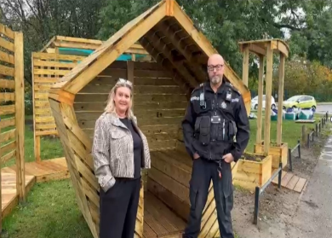
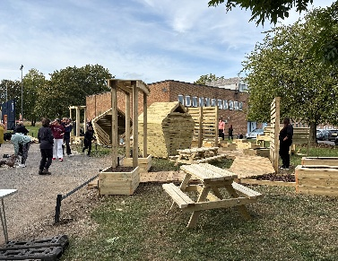
On the 28^{th of} September 2026 Team Hub had the official opening of the community garden. PCSO 6094 (sally) was in attendance sally and other members of the team our proud to celebrate the great work the community Hub is doing for our community. This is for the community please respect this area and reframe from using for smoking and damaging this area. Police will deal with any persons disrespecting this area.


Update on the the Motocyclist from last month
After some great contact from the local residents who were concerns for the safety of this incident. A male was identified and Sgt Walters and PCSO Brown (6083) attended an address and section 59 warning was issued. The bike is no longer in the area, hopefully this action taken will give residents a bit more peace and security.
Thank you to all the resident that brough this issue to our attention

With Dark Nights and loads of up-and-coming events, lets celebrate safely and Respect others

Bonfire Night
Diwali
Christmas

Halloween



Parties

