Welcome to your Rutland North police e-newsletter. Here you will find all of the latest news from a Rutland North policing perspective.
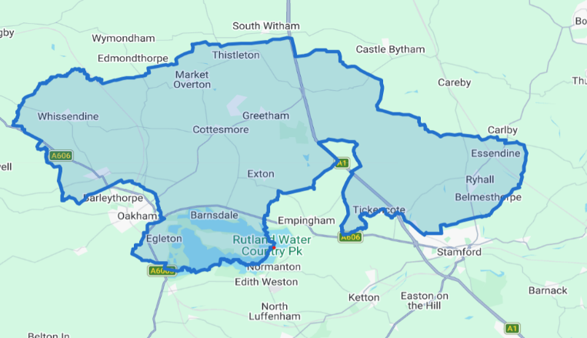
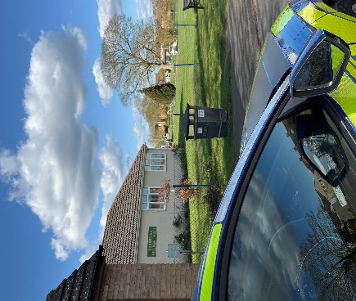

What matters to you

We have listened to you and the concerns you have raised through surveys, community consultations and analysing crime trends.

Rutland North Newsletter
August 2026 | PC Bland and PCSO Lyall
Using this data, we have created the following Rutland North priorities that the Dedicated Neighbourhood Team will focus their efforts on:

Page 1

Rutland North Beat

Priority 1: Burglary: Throughout August, the Rutland North Team has been actively tackling burglary-related offences across the area through proactive patrols, intelligence-led activity, and engagement with local communities. Officers have been speaking with residents about home security and crime prevention measures, offering practical advice to help reduce the risk of burglary and keep properties secure.

Priority 2: Road Safety:
Throughout August, the Rutland North Team has been carrying out proactive road safety activity across the area, focusing on locations highlighted by residents and intelligence received from the community. Officers have conducted targeted patrols, vehicle stops, and document checks to address concerns and promote safer use of the roads. As a result of this activity, a number of vehicles have been stopped and seized for offences including having no insurance, no tax, and involvement in suspected criminal activity. Investigations into several of these matters remain ongoing, with officers continuing to gather evidence and pursue further lines of enquiry.
Priority 3: Rural crime:
During July, PC Bland and I have been working to tackle rural crime through high-visibility patrols across rural locations, including farms, isolated properties, and areas vulnerable to theft and poaching. We have engaged with farmers, landowners, and members of the rural community to discuss concerns, provide crime prevention advice, and encourage the reporting of suspicious activity. We have also carried out reassurance visits and gathered intelligence to help identify and disrupt those involved in rural crime.

Through-out August, the Rutland North Team has remained busy responding to a wide range of incidents and concerns across the area. Alongside responding to calls for service, officers have been carrying out proactive patrols, engaging with local residents, and addressing issues raised by the community. The team has also continued to support ongoing investigations through intelligence gathering and partnership working, taking positive action to tackle crime and anti-social behaviour where identified.

0 Burglary related offences
2 reports of rural crime 1 report of road safety

August 2026

Rutland North Newsletter

Crime data for the last 30 days

In the last 30 day there have been:

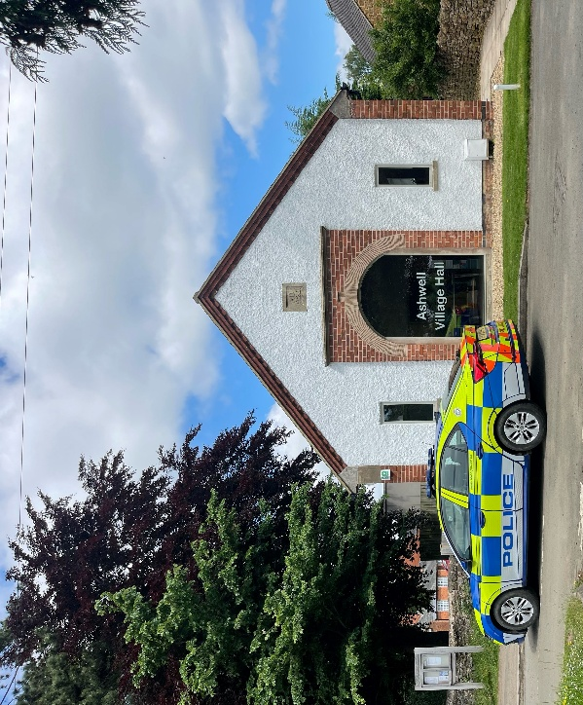


Community engagements—come along and meet the team!

23.09.2026 - 14:30- Cottesmore village hall beat surgery

