

Rushey Mead Beat
Newsletter
leics.police.uk

Issue: October 2026

BEAT SURGERIES Beat Officers
Below is a list of places where you’ll find your local beat team throughout November 2026. It’s a great chance to stop by and chat with us about anything happening in Rushey Mead.
PS O’Flynn PC Monohan PC Bramley PC Patel
PC Wallis PCSO McKeown
PCSO Khalifa

14/11/26 – Rushey Mead Library (Local officer drop-in) 11:30-
12:30
18/11/26 – Aldi on Fletton Close (Local officer drop-in) -
10:30am-11:30am
26/11/26— Sainsburys Melton Road (Local officer drop-in) -
10:30—11:30

The Rushey Mead Beat Team would love to hear your views on local problems in your area. If you are unable to visit one of us at the above beat surgeries. Please click HERE to complete a survey. This will allow us to gather information and review issues for the coming month.

BEAT PRIORITIES
Road Safety - Results from "my views" survey conducted by the local team, via Neighbourhood Link, indicate that this is a priority concern in the Rushey Mead area. This includes speeding, bad parking, use of mobile phones, drink and drug driving Key locations include Gipsy Lane /Gleneagles Avenue / Peebles Way and outside local schools.
Street drinking— Reports of street drinking in the local area have been highlighted by residents.
Anti-Social Behaviour- Drug use and drug dealing in green and open spaces has been identified by both surveys completed and by your local beat team through various patrols within the area.
Neighbourhood Link
Neighbourhood Link is an easy, free email messaging service from Leicestershire Police, Neighbourhood Watch and other local partner organisations, providing news and updates on policing matters that are relevant to you. Sign up to receive email alerts about police activity and initiatives in your local area, crime prevention advice and infor-mation and warnings about current scams and fraud. You’ll have the opportunity to reply directly to your neighbour-hood team and have your say on your local policing priorities.

Sign up to Neighbourhood Link: www.neighbourhoodlink.co.uk

#YouSaidWeDid
We did - We’re Taking Action on Road Safety - We’ve been working closely with our partner agencies, listening to your concerns and taking action to improve road safety across the Rushey Mead area.
- You’ll see your local beat officers carrying out patrols at schools during key times to help keep pupils, parents, and other road users safe. We’ll also be offering advice and taking action around child car seats and seatbelt use.
- We’re working closely with the council and partner agencies to help tackle and improve parking issues in your area.
- We’re also committed to identifying and dealing with those using vehicles without the correct documentation, such as a valid driving licence or insurance.
- Please contact the team if you have any concerns.
We're Taking Action on Street Drinkers - Our Dedicated Neighbourhood Officers will look to focus on dealing with this rising trend and the types of anti-social behaviour which stems from it.
- Officers have liaised with the council and have completed patch walks within the located areas.

We Did -We’re Taking Action on ASB - The beat team will continue to develop intelligence based on drug dealing
within the Rushey Mead area.
- Local officers will conduct stop searches where grounds apply and show a high visibility presence within the area.
- We will actively engage with members of the public and encourage you to inform us of the concerns that you have.
- Our hot spot areas for drug issues includes areas of the Three Kilns Car park, Sandfield Close and Lockerbie Ave-nue. Officers have focused on these areas and will continue to.
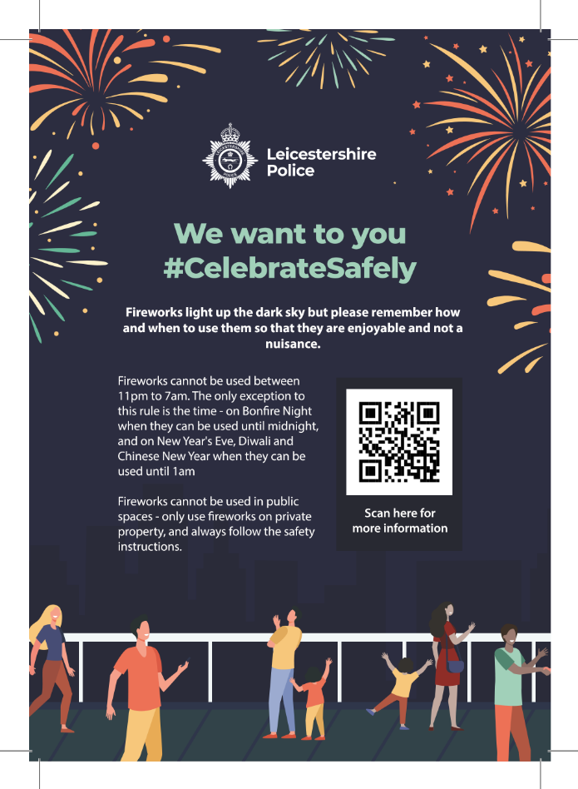
Fireworks can be enjoyable, but please use them responsibly and be considerate of neighbours, pets and the wider community. Fireworks should only be used on private property, never in public places, and the safety instructions must always be followed.
There are also legal restrictions on when fireworks can be used. Please plan ahead, follow the law and help ensure celebrations remain safe and enjoyable for everyone.
Scan the QR code on the leaflet for further fireworks safety information and guidance.
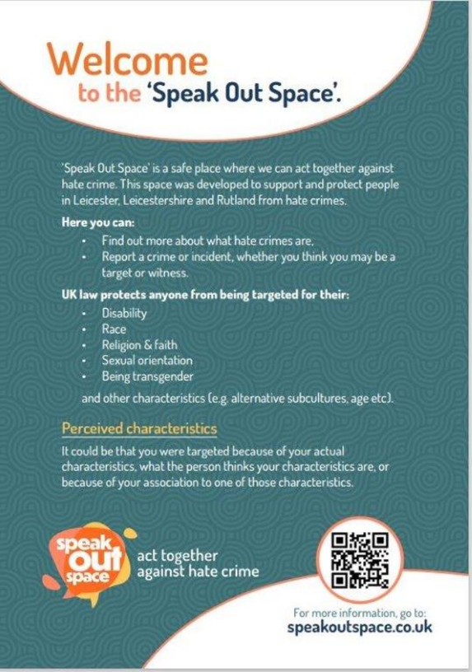

Sign up to Neighbourhood Link: www.neighbourhoodlink.co.uk

💙 COMMUNITY ENGAGEMENT | RUSHEY MEAD BEAT TEAM 💙
👮‍♂️ PC 4039 Patel and PCSO 6043 Khalifa from the Rushey Mead Beat Team recently visited Shree Dham Haveli, a local temple on our beat, to engage with the community and share important crime prevention advice.

🤝 Raising awareness of Hate Crime
During our visit, we spoke with community members and leaders about the importance of recognising and reporting hate crime. We distributed posters and leaflets providing information on how to report hate crime and where to seek support.

Everyone deserves to feel safe, respected and welcome in our community. 💙

🙏 Celebrating Navratri safely
With Navratri celebrations taking place, we also asked community leaders to help share important safety messages with worshippers and the wider community.

💎 Help us prevent jewellery theft:
🔹 Keep valuable jewellery out of sight when not being worn.
🔹 Store jewellery securely in a locked location when not in use.
🔹 Avoid leaving valuables unattended, particularly during busy celebrations and gatherings.
🔹 Stay vigilant and report any suspicious activity to police.

By working together and sharing these messages, we can help everyone enjoy the Navratri festivities safely while reducing opportunities for thieves.

A big thank you to the team at Shree Dham Haveli and the community leaders for their time, cooperation and continued support.

Working together to keep Rushey Mead safe, informed and united. 👮‍♂️🤝

#OnTheBeat

🚔 RUSHEY MEAD BEAT OFFICERS – WARRANT EXECUTED 👮‍♂️

PC 4039 Patel and PC 4736 Monohan, from the Rushey Mead Beat Team, have arrested a man who was wanted on a court warrant for failing to attend court when required

The male was transported to Euston Street Police Station, where he was processed before being taken directly to court.

⚖️ A reminder to the public: If you are required to attend court, it is important that you do so. Failing to attend without a valid reason can result in a warrant being issued for your arrest.

Our officers will continue to take positive action to locate wanted individuals and help ensure that those required to attend court are brought before the courts.

👮‍♂️ Rushey Mead Beat Team – keeping our community safe.

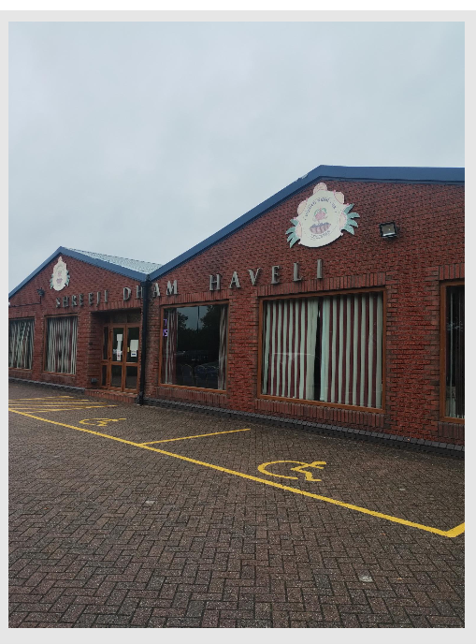
Sign up to Neighbourhood Link: www.neighbourhoodlink.co.uk
#OnTheBeat

