
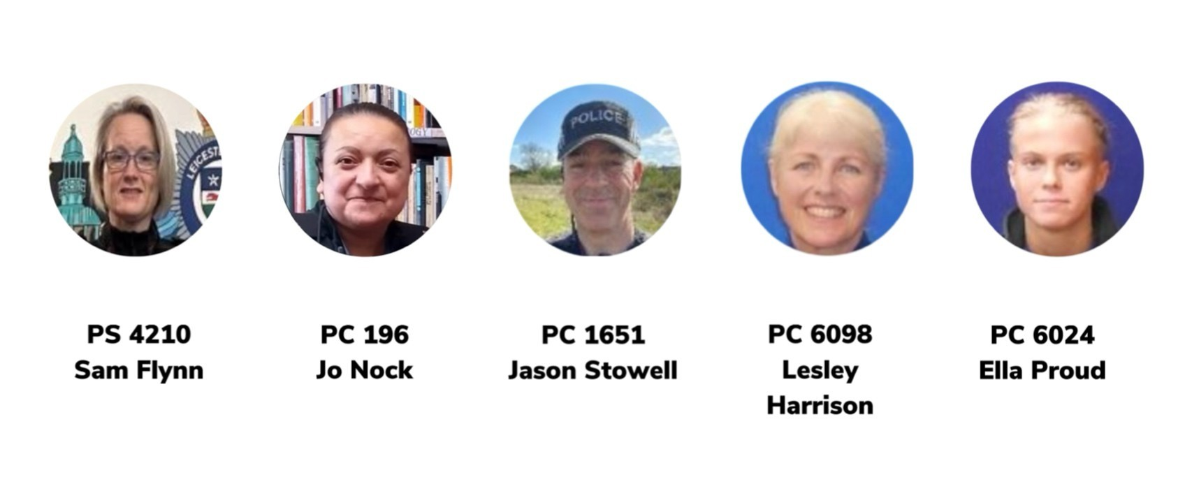
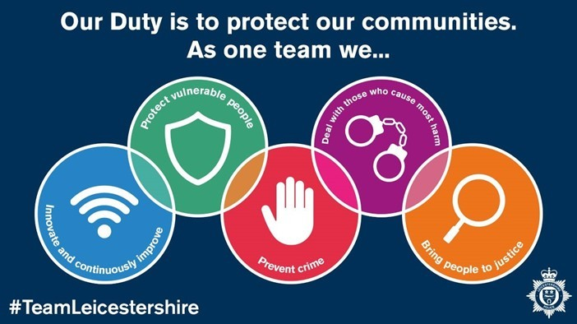
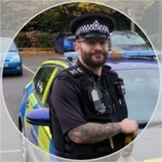

We have listened to you and the concerns you raised and will prioritise the following,
PCSO 6024

Issue:

May 2026
Charnwood East

Newsletter

Your Local Team

What matters to you

PC 743

PS 4017

PCSO 6098

John Merola
• Priority 1 - What you have said:
We have received reports of groups of youths causing issues within NL61 area, especially in Syston and Thurmaston.

Action taken
Reports of anti-social behaviour involving groups of youths within the NL61 area, particularly Syston and Thurmaston, have continued to be actively addressed. Targeted high-visibility patrols have been conducted during peak times in identified hotspot locations, with officers engaging directly with young people to challenge behaviour and set clear expectations.
We have successfully identified and reported several individuals responsible for anti-social behaviour involving motorbikes in Thorpebury-in-the-Limes and Thurmaston, taking positive action to disrupt ongoing issues in these areas.
Following ongoing intelligence development and neighbourhood tasking, two key perpetrators responsible for instigating disorder have now been identified and arrested for public order and offensive weapons offences. This represents a significant step in disrupting the core individuals driving the behaviour.
In addition, we have been assisting CID colleagues with the investigation into the fire at Thurmaston Retail Park, working to link numerous incidents of criminal damage reported overnight between 19th and 20th June 2026. Evidence has been actively gathered to support this investigation and progress enquiries.
A problem management plan remains in place, with neighbourhood officers working closely alongside East Leicester teams to robustly manage those involved and pursue proportionate enforcement action. Intelligence continues to be reviewed to monitor emerging trends, repeat locations and nominals.
Engagement remains a priority, with beat surgeries continuing to provide opportunities for the public to raise concerns and receive updates. Partnership working with the local authority and youth services is ongoing, ensuring a joined-up approach to prevention and early intervention, alongside the appropriate use of ASB powers where thresholds are met.
- Priority 2 - What you have said: There has been an increase in reports of theft from vehicles across the NL61 area.

Page 1

Charnwood East newsletter

Action taken
In response, targeted patrols have been conducted in identified hotspot areas, particularly during peak offending times. Officers have reviewed incident data to identify patterns, with CCTV and forensic opportunities explored where available.
As part of proactive enforcement activity, one prolific offender has been identified and arrested, and has subsequently been bailed with conditions to remain outside of the area whilst enquiries are ongoing. This action is intended to disrupt further offending and provide reassurance to affected residents. Engagement has taken place with residents to provide crime prevention advice, including the importance of securing vehicles and removing valuables. Beat surgeries continue to be held locally, allowing members of the public to raise concerns directly with officers and discuss ongoing issues and preventative measures. This activity will continue through intelligence-led tasking, targeted patrols and ongoing community engagement, alongside partnership working where appropriate, to reduce further offending and provide reassurance across the NL61 area.

- Priority 3 - What you have said: Reports of increased shoplifting have been received in the NL61 area.

Action taken
Reports of increased shoplifting within the NL61 area continue to be proactively addressed. Targeted patrols have been conducted around affected retail premises, informed by incident data and peak offending times. Officers have engaged with store staff to gather intelligence, review CCTV where available and provide tailored crime prevention advice. Repeat locations and nominals are being actively monitored through neighbourhood tasking.
As part of this ongoing work, one prolific offender has been identified, arrested, and remanded into custody, where they are currently awaiting a court date in relation to a Community Behaviour Order (CBO) application. This represents positive action in tackling one of the highest harm individuals contributing to shoplifting within the area. Beat surgeries continue to take place, providing opportunities for local businesses and members of the public to engage with officers, raise concerns and discuss ongoing issues. Officers are working closely with the Safer Streets team to identify and target the most impactful offenders. Robust enforcement action is being pursued where appropriate, including the continued use of CBOs to prevent repeat offending and protect local businesses. This activity will continue through intelligence-led patrols, strong partnership working and proportionate enforcement, with the aim of reducing shoplifting and providing reassurance across the NL61 area.

Everyday your local beat team are conducting marked Police car patrols through the villages of Charnwood East. These villages are Syston, Thurmaston, Thrussington, East Goscote, Ratcliffe on the Wreake, Barkby,
Barkby Thorpe, Beeby, Rearsby, Hamilton Lea, Queniborough, South Croxton and Thorpebury in the Limes.
Thank you to those who came to our beat engagements this month. Thank you to those for raising their concerns and for all the positive feedback.
We’re pleased to update that the team have successfully reported individuals responsible for riding motorbikes in an anti-social manner in both Thorpebury-in-the-Limes & Thurmaston, following police enquiries and evidence gathered, offences include riding on a bridleway, driving without a licence or insurance and drive without due care and attention. 📝

This outcome highlights how offences of this nature can be identified and dealt with when evidence is obtained. 📸British Legion Club in Thurmaston.
On 23/04, PCSO 6024 and 6098 carried out a beat surgery  at Thurmaston Retail Park.  We spent time speaking with members of the public and localstaff, listening to concerns raised and offering reassurance and advice.  We would like to thank everyone who took the time to | Officers have arrested a male for breaching his interim Sexual Harm Prevention Order. In Rearsby This was obtained by the beat team and we are working closely with Charnwood Borough Council regarding a breach of civil injunction. The investigation is ongoing, and we will update when we can.
Good News!!

- Three youths have been arrested for the fire at Thurmaston Retail Park and the beat team are conducting enquiries to try and link them to criminal damage to vehicles in Syston and Thurmaston.

stop and chat with us. Your feedback is important and helps.

On 15/04, PCSO 6024 conducted a beat surgery at Syston Town Square, engaging with local residents and business's, providing advice, and offering reassurance.



Page 2

Charnwood East newsletter

The Beat Team News

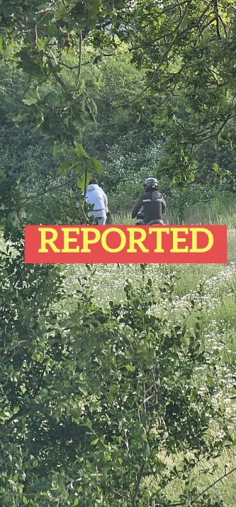



The Beat Team news

  Saturday 4th July at Thurmaston retail Park from 11:00am – 12:00
  Tuesday 14th July at Quenibean in Queniborough from 12:00 – 13:00
  3rd June 2026
  12:30PM - 13:30PM
  Queni Bean, Queniborough
We also do pop up beat engagements throughout the month various different locations please keep an eye out for these which will be posted on the below social media pages and Neighbourhood Link.
We have numerous engagements every month!
Upcoming engagements:
For more information, please follow us on our social media and check out our force website!
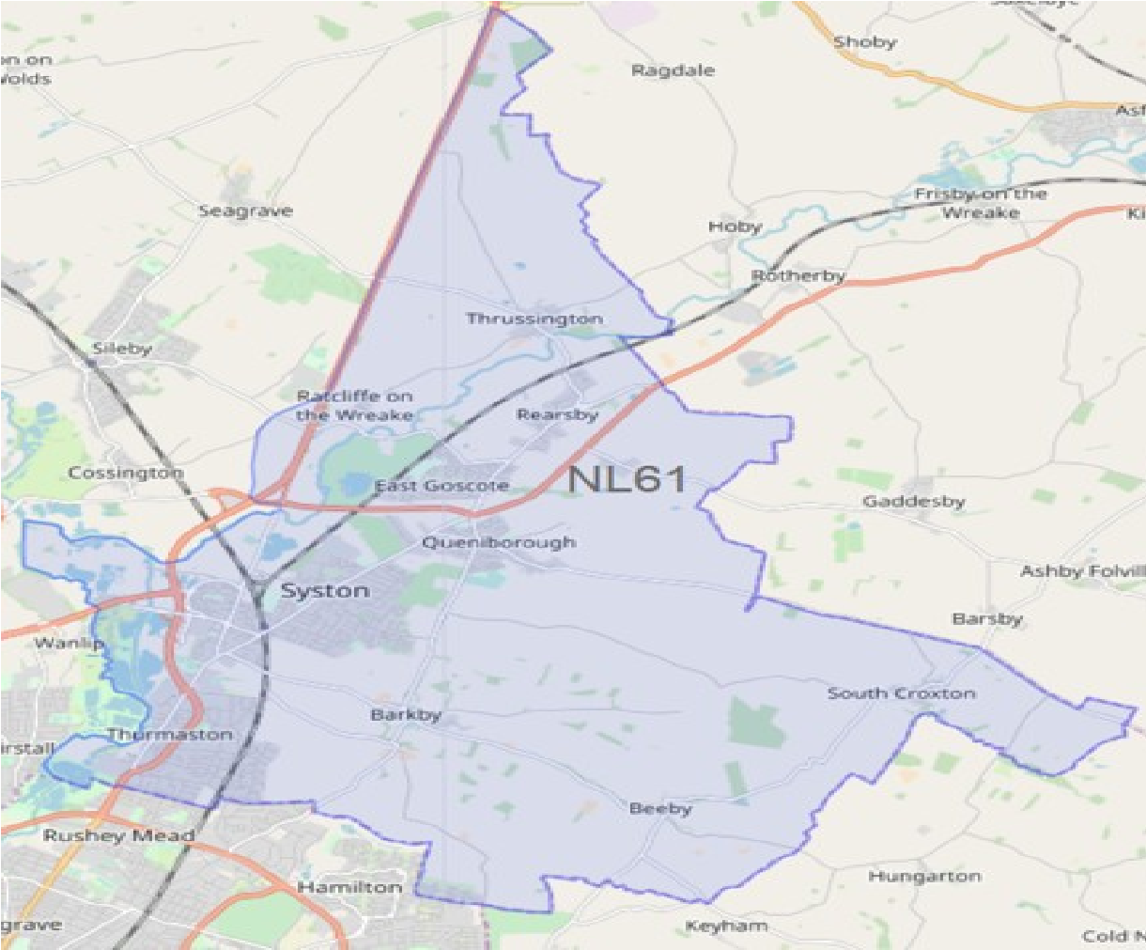
-

Syston

-

Queniborough

-

East Goscote

-

Thurmaston

-

Barkby

-

Barkby Thorpe

-

Thorpebury in
the Limes

-

Beeby

-

Rearsby

-

South Croxton

-

Thrussington

-

Hamilton Leas

-

Ratcliffe on the Wreake

MAP OF CHARNWOOD EAST:

Charnwood East

