
Issue: October Edition 2026
Melton Mowbray Town Centre Newsletter

The NR31 Beat Team
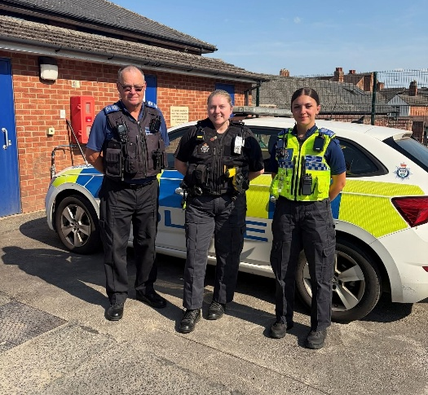

- PC 1836 Lucy Baxter

- PCSO 6131 Malcolm Durrant
- PCSO 6017 Etienne Kennington-Dawe
What matters to you

We have listened to you and the concerns you raised and prioritized the following:
Priority 1: Antisocial Behavior
The community has raised the issue of Anti-Social Behavior on the Melton Town Beat as a top priority this month
What we have done: Hot spot patrols are in place for this across areas of concern.
Anti-social behaviour remains one of our highest priorities on the Town Centre Beat due to the significant impact it is having on local businesses, residents, and visitors. Recent incidents involving youths accessing roofs, climbing scaffolding, causing criminal damage, and engaging in other disruptive behaviour have created safety concerns for both the individuals involved and the wider public. We have been taking a proactive approach, engaging with young people at the time incidents occur and working to address the root causes of this behaviour through early intervention and targeted problem-solving.
Alongside increased patrols and enforcement where appropriate, we are working with local businesses and property owners to reduce opportunities for anti-social behaviour by identifying and restricting access points to roofs and other vulnerable locations. We are also encouraging businesses to remain vigilant, report incidents promptly, and share information with us so that we can respond quickly and effectively. By combining visible policing, partnership working, early intervention with young people, and environmental improvements, our aim is not only to tackle current issues but to prevent future occurrences and make the town centre a safer and more welcoming place for everyone.

Priority 2: Drug Dealing

The community has raised the issue of drug dealing on the Melton Town Beat.

What we have done: Closure Orders and Partial Closure Orders have been executed at several addresses, with further action planned at other locations of concern. Patrols have been increased to ensure compliance and provide reassurance to the community. Officers continue to receive and gather intelligence on a daily basis regarding individuals and addresses linked to criminality and anti-social behaviour, allowing proactive patrols and enforcement activity to be targeted where they are needed most.

Priority 3: Theft and Burglary
What we have done: Theft and shoplifting remain ongoing challenges within the town centre and continue to have a significant impact on local businesses. As a team, we are committed to reducing these offences through high-visibility patrols, targeted activity at known hotspot locations, and close partnership working with retailers. With the busy Christmas trading period approaching, we will be further increasing our patrols and engagement with businesses to deter offenders, identify those responsible, and provide reassurance to the community. We encourage businesses and members of the public to continue reporting incidents promptly, as this information helps us respond effectively and take action against those involved.

We have listened!
Last month, PCSO 6017 shared a QR code survey asking for your views on issues affecting our roads. While the survey was not specifically focused on the Town Centre Beat, we were keen to hear the concerns of the wider community. The results showed that 90% of respondents believe there are safety issues on our roads. The three most common concerns raised were:
Speeding Vehicles, Parking, Noisy Motorbikes

The survey also highlighted the frequency of these issues, with respondents reporting that they are a regular occurrence within the community. In particular, 100% of those who completed the survey stated that they witness road-related issues on a daily basis, with incidents most commonly occurring during the late afternoons and evenings.

Following these results, we have been taking action where possible. Many residents may not be aware that police only deal with certain parking offences, such as vehicles causing a danger or obstruction to other road users. We continue to work with partner agencies where responsibility lies elsewhere.

Some of the work taking place includes:
- Increased engagement with motorists and motorcyclists.
- Advice being given to riders regarding excessively noisy exhausts that cause nuisance within the community.
- Identification of roads most commonly reported for speeding concerns.
- Planning targeted speed enforcement operations on hotspot roads.
- Ongoing monitoring of public reports to help direct our patrols and enforcement activity.

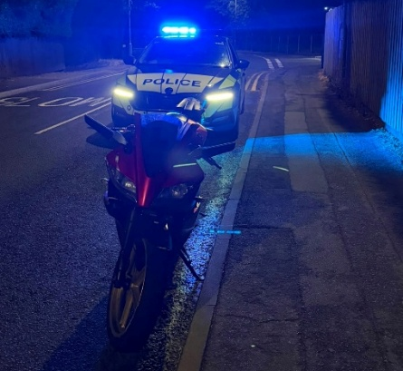
We would like to thank everyone who took the time to complete the survey. Your feedback helps us identify community concerns, direct our resources, and focus our efforts on the issues that matter most to local residents and businesses.

What we have been up to over the month!

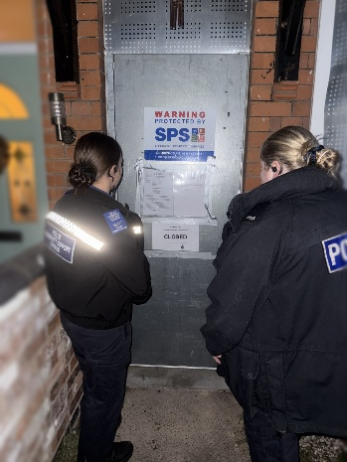
- On the 17th, PCSO 6017 and PC 1836 worked alongside the Safer Communities Team and Tenancy Services Team at Melton Borough Council to secure a Closure Order on a local property.
A Closure Order is a measure used to temporarily close a property that has become associated with ongoing anti-social behavior or criminal activity, helping to protect residents and improve the quality of life in the surrounding area.

- PCSO 6131 has been involved in advertising for Hate Crime Awareness week! On the 11th of October he attended McDonalds in order to speak to members of the public, and to spread awareness about Hate Crime!

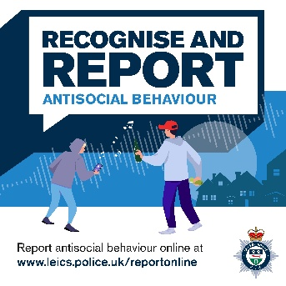
- On the 23rd PCSO 6017, accompanied by Inspector Rowan Patterson-Bell, attended a meeting to address the local concerns around Anti-Social Behavior. During this meeting we covered several subjects and answered a lot of questions! All these have been addressed in the Inspectors post on Facebook on the 23rd.
Over the month, we have also dedicated extra, and more in-depth patrols of the beat in the evening times to providing reassurance in the town.
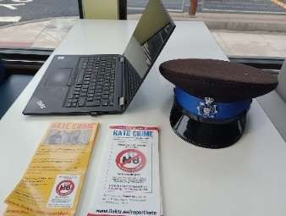


17/11/26 @15:00 - Steam and Bean
Community engagements

24/11/26 @10:00 - Cattle Market
14/12/26 @10:30 - The Library
11/01/27 @09:00 - Melton Bid, Bell Centre
16/02/27 @11:30 - The Air Ambulance Café

More to be confirmed…

For the future

Please continue to report any suspicious activity to the police on either 101 or on the website.
Thanks for reading the newsletter!

Contact us on:
Melton Police - FACEBOOK
101 – NON EMEGENCIES
999- EMERGENCIES
Melton Station Front Desk.

