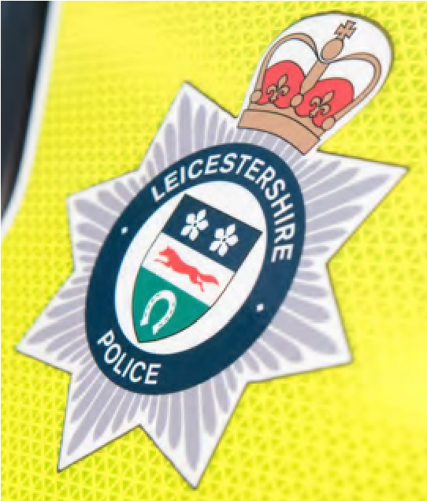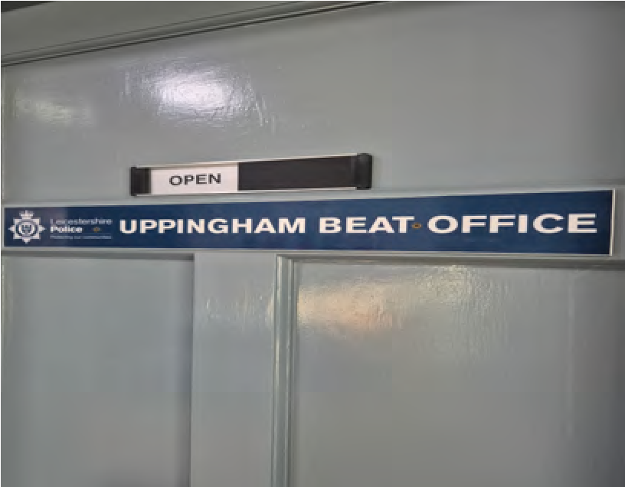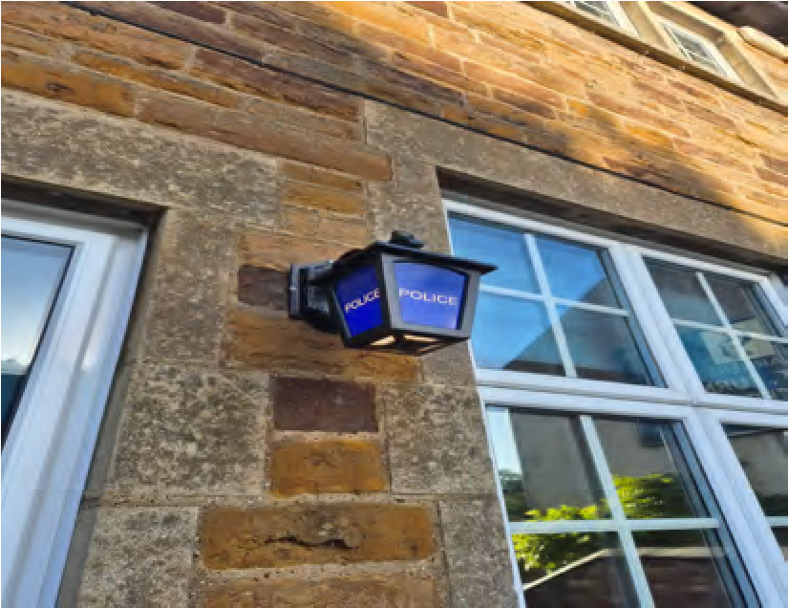
Welcome to your
Uppingham
police e
-
newsletter.
What matters to you

We have listened to you and the concerns you have raised through surveys, community consultations and analysing crime trends. Using this data, we have created the following Uppingham Town priorities that the Dedicated Neighbourhood Team will focus their efforts on:
Road Safety:
You said: Speeding vehicles on Rutland roads is a priority you want us to address, specifically the lack of adherence to 30mph zones.

During September, high-visibility patrols were carried out across Uppingham and the surrounding area, with a focus on road safety and addressing concerns raised by residents regarding the manner in which some vehicles, particularly motorbikes, are being ridden and driven.
A number of vehicles have been stopped and checked throughout the month, with officers engaging positively with motorists and taking enforcement action where appropriate. Several matters have been identified as a result of these proactive checks, with enquiries commenced and investigations remaining ongoing.
We are aware of ongoing concerns relating to motorbikes causing issues on the roads in and around Uppingham. In response, officers have conducted numerous stop checks, obtained the details of riders, and issued words of advice and warnings where standards of driving or riding have fallen below what is expected. Patrols will continue in identified hotspot areas, with action being taken where offences are detected.
We remain committed to improving road safety, addressing community concerns, and ensuring that those using our roads do so responsibly and considerately.

Drugs:
You Said: Drug dealing as well as drug use in the area.
What we have done:

During September, officers have continued to carry out high-visibility patrols in Uppingham town centre and surrounding areas in response to community concerns surrounding drug use, drug dealing, and associated anti-social behaviour. Additional evening patrols have been introduced to provide reassurance to residents, deter offending, and address reports of ASB during peak times.
Through proactive patrols, engagement with local residents, and intelligence-led policing, officers have identified individuals suspected of being involved in drug-related activity and have taken appropriate action where necessary. Information gathered from the community continues to play a valuable role in helping us build intelligence and develop investigations.
We remain committed to tackling drug-related offending and the impact it has on the local community. Targeted patrols and enforcement activity will continue, alongside ongoing intelligence gathering, to disrupt criminal behaviour, reduce anti-social behaviour, and keep Uppingham a safe place to live, work, and visit.

Anti-Social Behaviour:
You said: Specific issues of Anti-Social Behaviour (ASB) concerning individuals in the community and ongoing ASB issues in the town centre.

What we have done: During September, we have increased our focus on anti-social behaviour by introducing additional priority patrols in and around Uppingham. PC Stott and PCSO Wylie have spent time carrying out high-visibility foot patrols throughout the town whenever operational commitments have allowed, providing reassurance to residents and engaging positively with members of the community.
Officers have been actively dealing with ongoing issues reported at the Harley-Davidson garage and incidents of anti-social behaviour at Tods Piece. Thanks to information provided by local residents, we have been able to identify those involved in offending and progress investigations. This has resulted in arrests being made, with individuals subsequently released on bail with conditions while enquiries continue.
Community information remains vital in helping us tackle ASB and identify those responsible for causing issues within our neighbourhoods. We would like to thank residents for their continued support and for reporting concerns to us. We will continue to prioritise anti-social behaviour, carry out targeted patrols in identified hotspot locations, and take positive action against those whose behaviour negatively impacts our communities.

Neighbourhood Link
We continue to encourage local residents to have their say through Neighbourhood Link surveys, our aim is to keep all residents that have signed up to this aware of issues happening in Rutland.
Our policing priorities are set every quarter following returns of Neighbourhood Link surveys, along with crime pattern analysis data and issues highlighted by of our professional partners.
The more results we have from surveys, the better informed we are as to where to target resources.
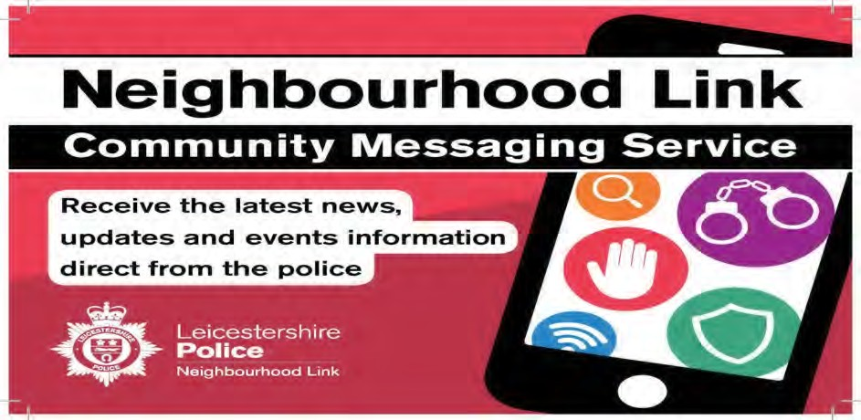
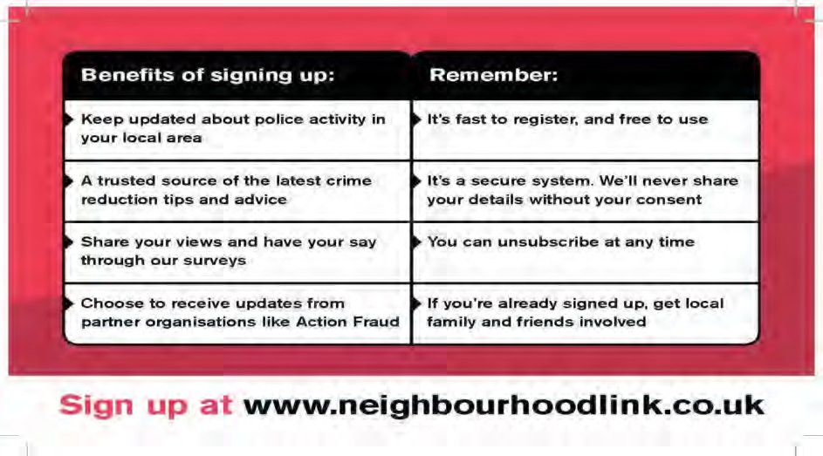
Uppingham Newsletter

Newsletter

Crime trends and Prevention advice
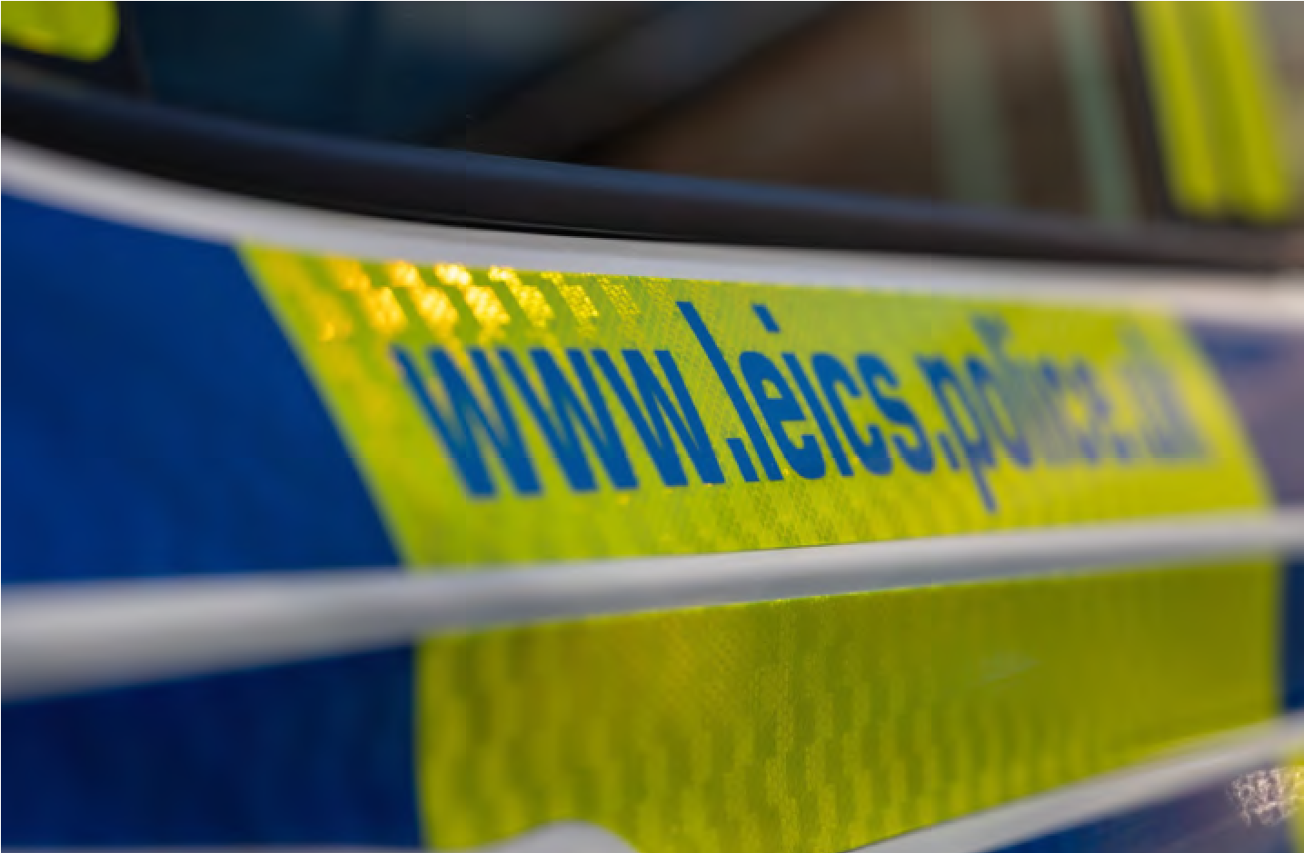

"Making it appear as though you are at home, is a quick and easy way to prevent burglaries. Some things you can do are: 💡 If you are out, use an automatic timer switch or smart lighting to turn on the lights when it gets dark, to make it look like someone is home. 🚨 Take time to check your alarm system, outdoor bulbs and security lighting works. 🏠 Ask a trusted neighbour, relative or friend to collect your post and open and close your home’s curtains whilst you’re away, to give the impression that someone is home. 📱 If you’re going away, don’t share details on social media until you return. You can find more crime prevention advice by visiting: https://www.leics.police.uk/cp/crime-prevention/protect-home-crime/keep-burglars-out-property/ Remember #LockUpLightUp."

- Keep valuables, keys, and vehicle keys out of sight.
- Consider installing a doorbell camera, CCTV system, or other home security measures.
- Avoid advertising holidays or periods away from home on social media until after you have returned.
- Report any suspicious behaviour or unfamiliar vehicles in your neighbourhood to the police.
We remain committed to tackling anti-social behaviour and drug-related issues that affect residents, businesses, and visitors. We encourage anyone who witnesses or experiences anti-social behaviour to report it to the police, as the information provided helps us build our intelligence picture, direct patrols effectively, and take action against those responsible. By working together, we can continue to keep Uppingham and the surrounding villages safe places to live, work, and visit.

