Uppingham
Newsletter
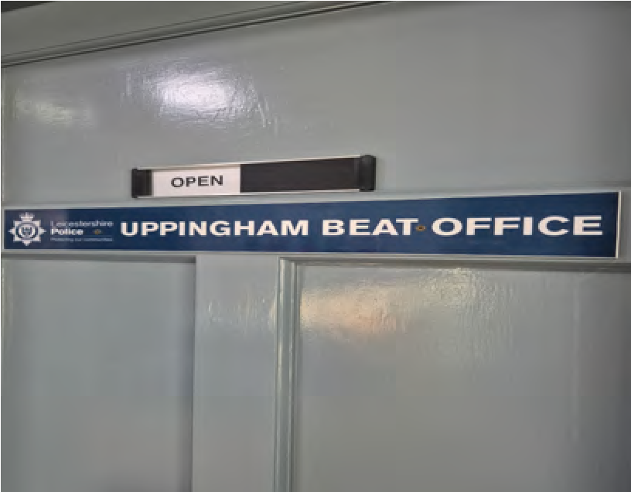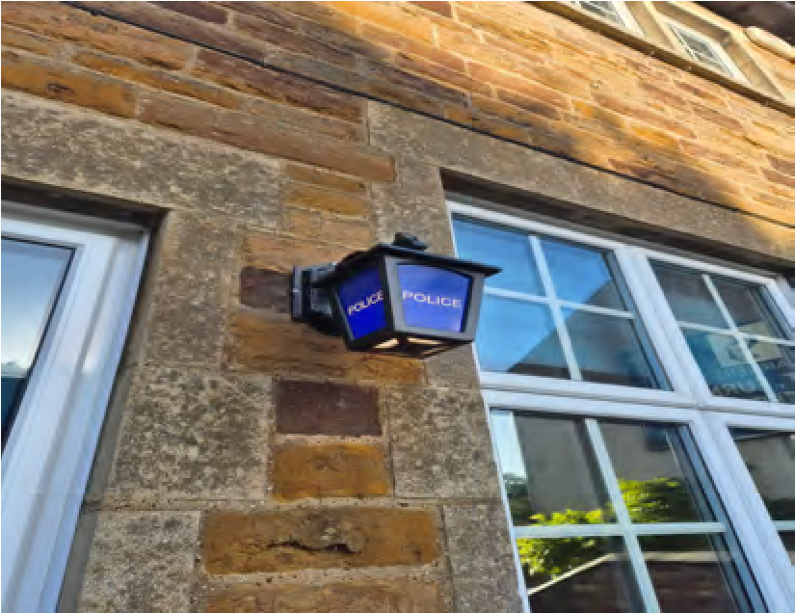
Welcome to your
Uppingham
police e
-
newsletter.
What matters to you

We have listened to you and the concerns you have raised through surveys, community consultations and analysing crime trends. Using this data, we have created the following Uppingham Town priorities that the Dedicated Neighbourhood Team will focus their efforts on:
Road Safety:
You said: Speeding vehicles on Rutland roads is a priority you want us to address, specifically the lack of adherence to 30mph zones.
What we are going to do: We will complete high visibility patrols of hotpot areas with partner agencies and deal proactively with offenders with a view to providing suitable advice or action where required.
Drugs:
You Said: Drug dealing as well as drug use in the area.
What we are going to do: Develop our intelligence picture around those who commit this type of crime so we that we can effectively target our resources in the right areas, at the right time, with the aim of deterring, disrupting and bringing offenders to justice.
Anti-Social Behaviour:
You said: Specific issues of Anti-Social Behaviour (ASB) concerning individuals in the community, ‘nuisance neighbours’ and irresponsible dog ownership / walking is an area you want us to focus on.
What we are going to do: We will provide a frequent high visibility policing presence, as part of a localised operation around Road Safety, to the affected areas with marked vehicle patrols and regular monitoring. We will deploy the speed gun device and deal with offenders robustly where appropriate. We will also continue to work with partner agencies, such as the Road Safety Partnership mobile speed camera van, to identify areas of concern and request deployment of that resource. We will then continue to publish the enforcement statistics on the

What we have done #yousaidwedid
Uppingham Newsletter
June has been a busy month for the Uppingham Beat Team as we continue our commitment to keeping our communities safe and welcoming. Throughout the month, we have been proactively tackling anti-social behaviour across Uppingham and the surrounding villages through targeted patrols in hotspot locations and a coordinated team approach. Officers have been identifying and dealing with offenders, taking positive action where appropriate, and working to address issues before they escalate. Our increased presence in the area aims to deter anti-social behaviour, provide reassurance to residents, and maintain a safe environment for everyone who lives, works, and visits the area.

Uppingham Newsletter
Neighbourhood Link
We continue to encourage local residents to have their say through Neighbourhood Link surveys, our aim is to keep all residents that have signed up to this aware of issues happening in Rutland.
Our policing priorities are set every quarter following returns of Neighbourhood Link surveys, along with crime pattern analysis data and issues highlighted by of our professional partners.
The more results we have from surveys, the better informed we are as to where to target resources.
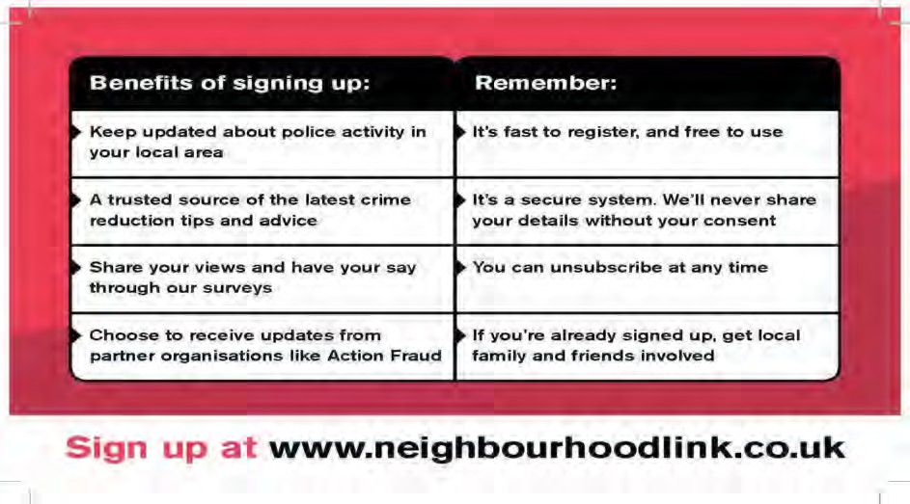
Uppingham Newsletter

Uppingham
Newsletter

Noteworthy crimes

VEHICLE CRIME
Damage to van
CRIMINAL DAMAGE

THEFT
Theft of fuel

Crime trends and Prevention advice
With the warmer weather and longer evenings, we have seen an increase in reports of anti-social behaviour across Uppingham and the surrounding villages. As more residents, visitors and young people spend time outdoors and within the town, there are naturally more opportunities for ASB to occur.
Throughout June, the Uppingham Beat Team has been proactively addressing these issues through targeted patrols in identified hotspot locations and by engaging with those involved. We have been taking positive action against offenders where appropriate, working with partner agencies and local businesses, and using information provided by the community to tackle concerns before they escalate.
While Uppingham remains a safe and welcoming place to live, work and visit, we recognise the impact that anti-social behaviour can have on residents, businesses and visitors. We will continue to maintain a visible presence across the area and encourage anyone experiencing or witnessing ASB to report it to us, as the information you provide helps us direct our patrols and resources where they are needed most.
With the summer holidays fast approaching, we would also encourage parents and guardians to speak with their children about anti-social behaviour and the effect it can have on the wider community. What may seem like harmless fun can often have a significant impact on local residents and businesses. By having open conversations about respectful behaviour and personal responsibility, we can all play a part in helping to ensure that everyone can enjoy the summer safely and respectfully.

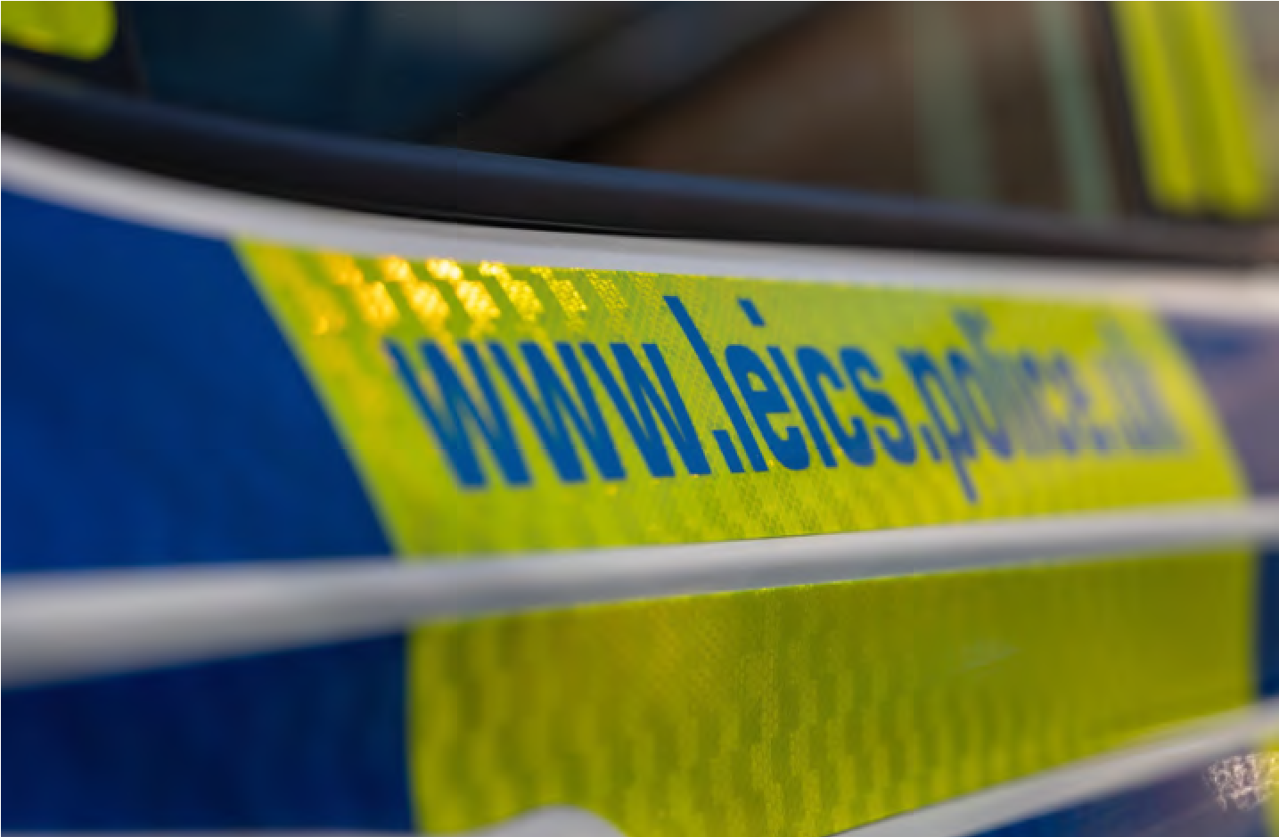

Uppingham Newsletter
Uppingham Newsletter
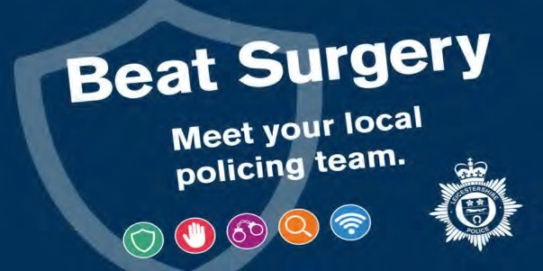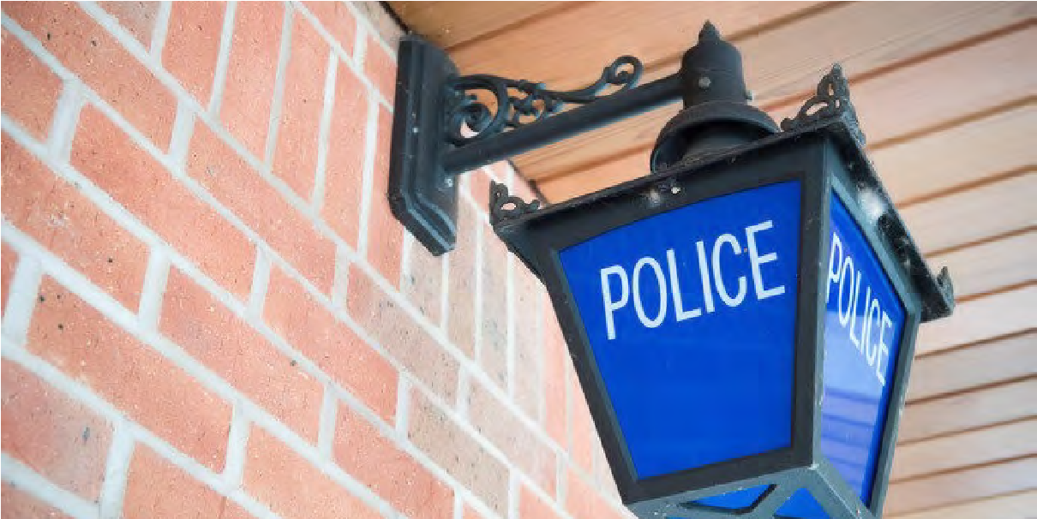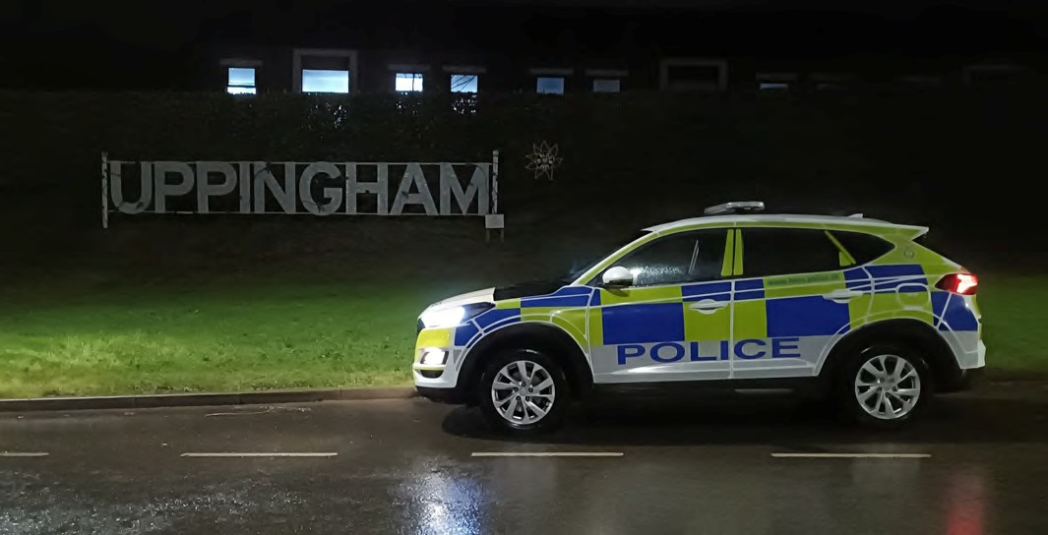
Uppingham
Newsletter
The next edition will be out soon!

BEAT ENGAGEMENTS:
Friday 12th December 10:00 - 11:00
Uppingham Methodist Church
Monday 15th December 17:00 - 18:00
Uppingham Town Hall
Dates for your diary
Follow us on Facebook
-
@RutlandPolice

Contact the team directly via email:

Email: PC
392 Melissa Stapleton
:

Melissa.stapleton
@leics.police.uk

Email: PCSO 6613 Andy Wylie:

Andy.wylie@leics.police.uk

Follow us & Contact info

