
Issue: August Edition 2026
Melton Mowbray Town Centre Newsletter

The NR31 Beat Team
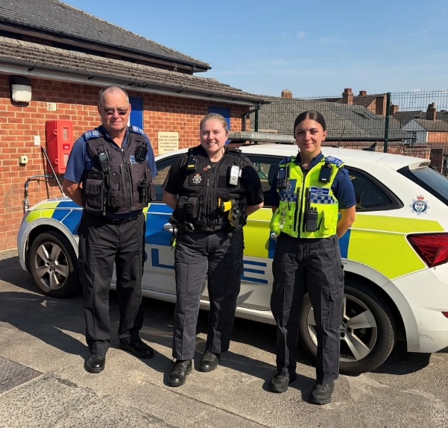

- PC 1836 Lucy Baxter

- PCSO 6131 Malcolm Durrant
- PCSO 6017 Etienne Kennington-Dawe

What matters to you
We have listened to you and the concerns you raised and prioritized the following:

Priority 1: Antisocial Behaviour
The community has raised the issue of Anti-Social Behavior on the Melton Town Beat as a top priority.
What we have done: Hot spot patrols are continuing with informed and targeted areas at the top of the list.
The school holidays did lead to an increase in incidents of ASB and with school holidays drawing to a close this historically will now lead to a decrease in incidents. The beat teams current patrol and control strategy remains in place and in conjunction with the Town Smart scheme will ensure that someone somewhere is always watching out for trouble. The vast majority of local youth are respectful and officers will always take time to engage with groups of young people but sadly it will always be the minority that cause issues and they are by and large well known to officers.

Priority 2: Drug Dealing

The community has raised the issue of drug dealing on the Melton Town Beat.

What we have done: During patrols, a number of stop searches have been conducted on both individuals and vehicles, resulting in the seizure of controlled drugs and the identification of persons involved in criminality.

In addition, we have continued to gather and develop intelligence relating to individuals and locations suspected of being involved in drug-related activity. This information is used to inform future patrols, targeted operations, and enforcement opportunities, enabling us to take a proactive approach to addressing concerns within the community and providing reassurance to residents, businesses, and visitors.

A couple of ‘major players’ involved in the local drug scene were taken down this month and those investigations are ongoing.

Priority 3: Theft and Burglary
What we have done: Preventing and reducing theft within the town centre continues to be a key priority.
We encourage retailers to continue reporting theft offences and sharing information through the DISC system, as this helps build intelligence, identify repeat offenders, and support enforcement action. By working closely with businesses and maintaining a visible presence within the retail environment, we aim to deter offenders, increase opportunities to identify those responsible for theft offences, and provide reassurance to businesses, employees, and members of the public.

As an example of how beneficial the collaboration work between local officers and retailers can prove it took less than 36 hours after a burglary in the town centre in the early hours of the morning to the suspect being identified and arrested the following day.

What We have been up to..
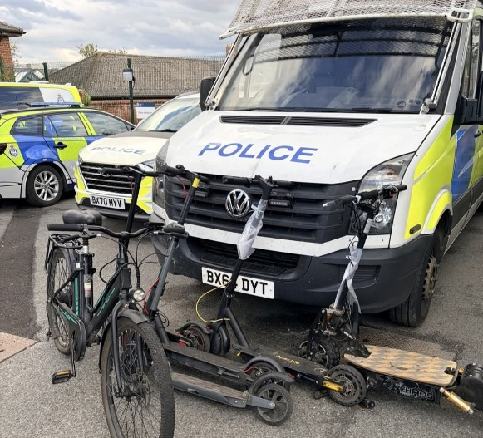
.
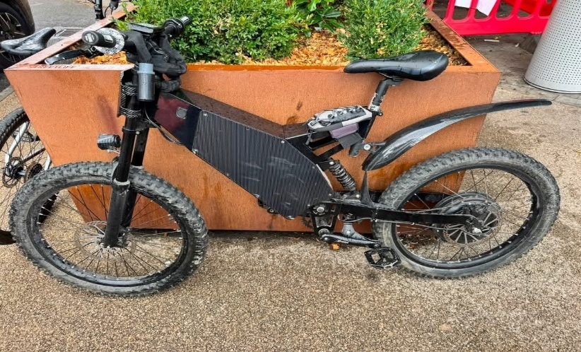

Throughout the month…
The beat team, supported by both the Safer Streets team and other officers carried out an Op Pedalfast which is aimed at the recent surge of illegal Ebikes and Escooters that have plagued the town centre over recent months. On this occasion numerous ‘vehicles’ were seized and whilst some could potentially be reclaimed others will be sent for destruction. As you can see from the second photo some bikes are better suited to Brands Hatch than Melton Town Centre. There will be further Pedalfast work taking place in coming weeks.

Community engagements

22/9/26- Beat surgery @ Cattle market
23/9/26- Beat surgery @ Library
6/10/26- Beat surgery @ the park


For the future

Please continue to report any suspicious activity to the police on either 101 or on the website.
Thanks for reading the newsletter!

Contact us on:
Melton Police - FACEBOOK
101 – NON EMEGENCIES
999- EMERGENCIES
Melton Station Front Desk.

